|  |
| --- |
| The procedure of clicking on the HTML radio buttons to change the format of the visualization is known as …………….   1. **Transitioning** 2. Transforming 3. Slicing 4. Indexing |
| In D3, Which tool is preferred to easily aggregate data and then merge the multiple aggregated files into a single file for visualization?  a) Splunk  **b) R**  c) Python  d) Data Manager |
| D3 helps put life into your data by utilizing   1. **Scalable Vector Graphics (SVG)** 2. Canvas 3. Standard HTML 4. All of the above |
| 4. JavaScript functions are used to read other data format in --------------------  a) R  b) Data Manager  c) Splunk  d) **D3** |
| ____ allows you to draw various forms such as lines, rectangles, circles, ellipses, and so on.   1. **SVG** 2. Shape 3. Array 4. Graphics |
| In data visualization, there should be ___________ in the order in which you display information.   1. **Logic in the order** 2. Colour Consideration 3. Adding Animation 4. Adding the Strategies |
| In which background support to focus data easily?  a) **White background**  b) Dark background  c) Light Element on a Dark Background  d) None of the above |
| A ……………is a line graph where the lines overlap a lot, making it difficult to focus on a single series at a time.  a) donut pie graph  b) Bar graph  c**) spaghetti graph**  d) scatter graph |
| ……………. are free, online, and shareable, allowing multiple people to edit.  a) **Google Spreadsheets**  b) Adobe Illustrator  c) Tableau  d) Python |
| ……………….. is a popular out‐of‐the‐box data visualization solution that can be great for exploratory analysis and it is expensive.  **a) Tableau**  b) data manager  c) R  d) python |
| **D3.js is a ____ library.**   1. **JavaScript** 2. Python 3. Java   Php |
| **In d3.js, a ____ is a function that maps input values to output values.**   1. Axis 2. Transition 3. **Scale**   Selection |
| A smooth, animated shift in the look or behaviour of components in visualization is referred to as a ____ in d3.js.   1. Events 2. **Transition** 3. Path 4. Layout   Selection |
| All DOM items are selected by matching the specified CSS selector using which of the following method?   1. Selects 2. AllSelects 3. **SelectAll**   None |
| **____ allows you to draw various forms such as lines, rectangles, circles, ellipses, and so on.**   1. **SVG** 2. Shape 3. Array   Graphics |
| In data visualization, there should be ___________ in the order in which you display information.   1. **Logic in the order** 2. Colour Consideration 3. Adding Animation   Adding the Strategies |
| _______ Used to build data competency in your team or Organization   1. **Storytelling** 2. Communicating with data 3. Data style   Different font, colour & graphs. |
| ____________is a popular out‐of‐the‐box data visualization solution that can be great for exploratory analysis because it allows you to quickly create multiple views and nice‐looking graphs from your data.   1. **Tableau** 2. D3 tool 3. R Programming   Trifacta |
| Which among the below set of colours are generally known as the primary colours of light?   1. White, yellow, Blue 2. **Red, Green, Blue** 3. Red, Green, Black   Black, White, Red |
| _______ approach separate spatially and emphasize a single line at a time, while leaving the others there for comparison but pushing them to the background.   1. **Combined approach.** 2. Separate approach 3. Logical approach   Strategical approach |
| D3.js stands for ____.   1. Data document and dom manipulation 2. **Data-driven documents** 3. Dom data documents   Document-driven data |
| In d3.js, a ____ is a collection of DOM items that match a particular selector.   1. **Selection** 2. Path 3. Events   Transition |
| Which is actually an open-source JavaScript library, designed with the intention of visualizing data using today's web standards?   1. D3 2. D3.js 3. D3.java   **Both a and b** |
| In Visual transitions, which button is used to change the format of the visualization?   1. Reset 2. **Radio** 3. Submit   Select |
| When dealing with manufacturing data, which is collects production data directly from the machine, stores it in memory, and periodically sends it off to the data repository?   1. Data manager 2. **Data logger** 3. Data Aggregator   Data handler |
| Visual transitions handle missing data by filling   1. Null values 2. Zeros 3. **Either null or zero**   None of the above |
| In which background support to focus more on the background?  a) White background  **b) Dark background**  c) Light Element on Dark Background  d) None of the above |
| Which Programming language does not support greater flexibility and control of the specific elements of the graphs?  a) R  b) D3 (JavaScript)  c**) Python**  d) Java |
| Some people use……………., either alone or together Excel or via a programming language, for easier manipulation of graph elements and a professional look and feel.  a) **Adobe Illustrator**  b) Adobe Photoshop  c) Adobe editor  d) Adobe pdf |
| This site allows you to submit a visual to receive feedback from readers or scan the archives for examples and corresponding conversations.  a) VizWiz  b) Junk Charts  **c) HelpMeViz**  d) Eager Eyes |

**Four Marks**

**1.Explain the procedure to draw a Multiple donuts chart using D3 with an example.**

1. Download the sample template and save it as an HTML document.



2. Change the src= reference (to a local reference for the D3 libraries).

3. Change the name of the data file.

4. Add a heading.

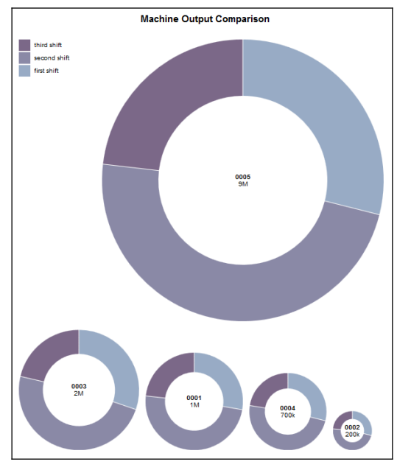

1. **Explain the strategies for leveraging animation in the visuals you present.**

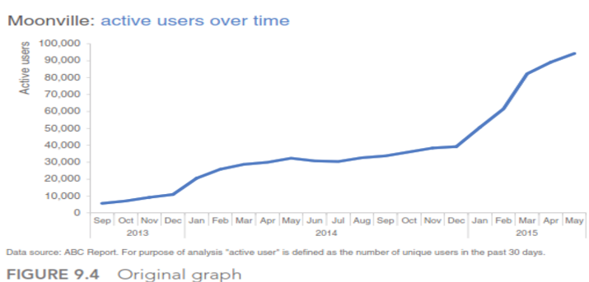

* you lose control over their attention.
* You might be talking about one part of the data while they are focusing somewhere else entirely.
* you want to tell the story chronologically,
* but your audience may jump immediately to the sharp increase in 2015 and wonder what drove that.
* When they do so, they stop listening to you.

Alternatives

Step 1

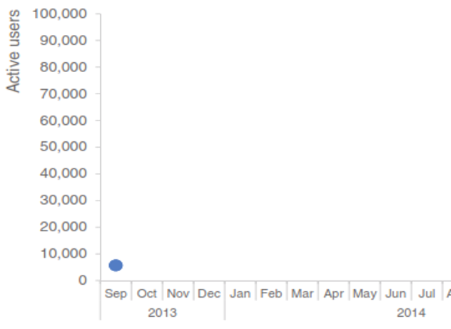

Step 2

Step 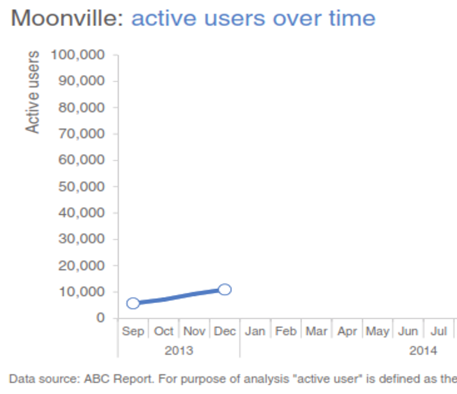

Step 3

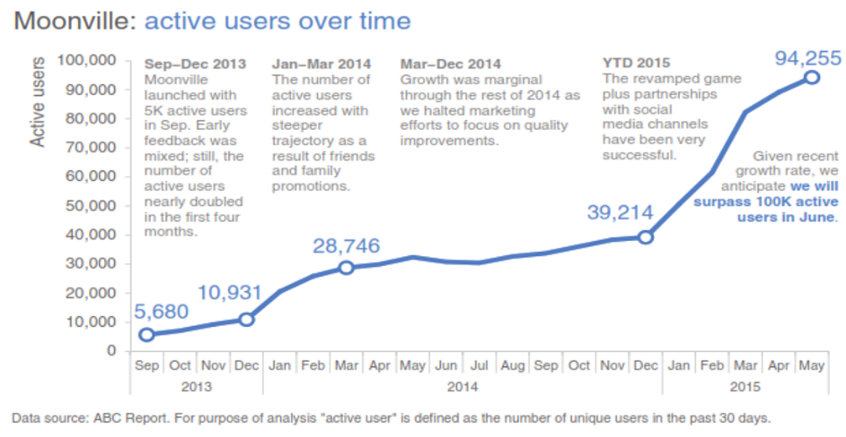

**3.Discuss the strategies for avoiding the spaghetti graph.**

* A spaghetti graph is a line graph where the lines overlap a lot, making it difficult to focus on a single series at a time.

Alternatives

* Emphasize one line at a time
* Separate spatially
* Combined approach
* Diagram

**4.Compare the D3 and Big Data**

Answer:

* We can easily bind or use your large datasets to common SVG objects using the functions available in the D3.js libraries.
* The data can even be in a variety of formats, most commonly JSON, **comma-separated values** (**CSV**), or **geoJSON**, but, if required, JavaScript functions can be written to read other data formats.
* However, large isn't big in the sense of big data. Realistically, binding a CSV file of 500 records cannot be likened to binding it to a file of 500,000 records.

So, can D3 really help in the context of big data? Since it is low-level, D3 may seem like a bad fit for big data visualization projects. The D3.js libraries just won't work with gigabytes of data, but once you perform some preprocessing on the data, D3 can help make sense of the results.

**5.List out the key features of D3.js?**

* Data Driven
* DOM Manipulation
* Interaction and animation
* Custom Visualizations - Pie chart, graphs, bar charts or geospatial maps

Transitions

**6. How to get started with D3.js.**

Answer:

* The website may be found at

https://D3js.org

* The latest version (at the time of writing) is V4.2.8, and that version can be downloaded from the following link:

https://github.com/D3/D3/releases/download/v4.2.8/D3.zip

* You can simply link directly to the latest release libraries by inserting the following line in your projects:

<script src="https://D3js.org/D3.v4.min.js"></script>

**7. List out popular tools for creating the data visualizations from your learning.**

Answer:

* **Google spreadsheets** are free, online, and sharable, allowing multiple people to edit (as of this writing, there remain graph formatting constraints that make it challenging to apply some of the  
  lessons we’ve covered when it comes to decluttering and drawing attention where you want it).
* **Tableau** is a popular out‐of‐the‐box data visualization solution that can be great for exploratory analysis because it allows you to quickly create multiple views and nice‐looking graphs from your  
  data. It can be leveraged for the explanatory via the Story Points feature. It is expensive, though a free Tableau Public option is available if uploading your data to a public server isn’t an issue.

**Programming languages**—like R, D3 (JavaScript), Processing, and Python—have a steeper learning curve but allow for greater flexibility, since you can control the specific elements of the graphs you  
create and make those specifications repeatable through code.

**8. Outline the five steps for storytelling with the data process.**

1. learn your tools well,
2. iterate and seek feedback,
3. devote time to storytelling with data
4. seek inspiration through good examples
5. have fun and find your style

**9. Explain in detail how D3.js selects the method.**

The **d3.select() function** in D3.js is used to select the first element that matches the specified selector string. If any element is not matched then it returns the empty selection. If multiple elements are matched with the selector then only the first matching element will be selected.

**Syntax:**

d3.select("element")

**Parameters:** This function accepts single parameter which holds the element name.

**Return Value:** This function returns the selected elements.

Below programs illustrate the **d3.select()** function in D3.js:

// Calling the select() function

**var** a = d3.select("div").text();

        // Getting the selected element

        console.log(a);

**10.Explain visual transition in D3 with an example.**

The procedure of clicking on the HTML radio buttons to change the format of the visualization is known as transitioning. In the preceding example, we transitioned from

one format to another. We can also use transitioning to change what data the visualization is driven from.

* This template transitions the visualization between Apples data and Oranges data:

http://blocks.org/mbostock/5681842

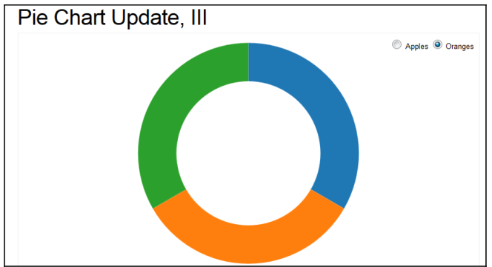

The usual steps are downloading the HTML template, locating and changing the D3 library reference, and updating the data.

Let's look at the three specific customizations:

Step1. I added a simple heading:

<center><H1>Parts by Shift</H1></center>

Step2. I changed the HTML form from apples to oranges to indicate our three plant shifts. Note that I had to add a third HTML radio button:

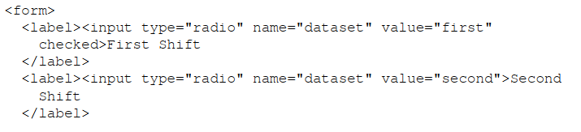

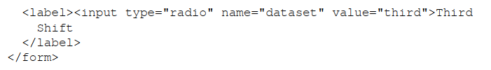

Step 3. I modified the function that handles missing data to validate all three shifts:

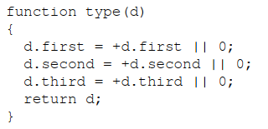

* Again, notice that I simply changed the references from apples and oranges to first and second, and then added a third reference, for our third shift.
* The last step is to pre-process our raw plant data into a summary file that this D3 template can use.
* It is a pretty simple file, with just two fields, apples and oranges (shown in the following screenshot). You will notice that the second field (oranges) is missing values:

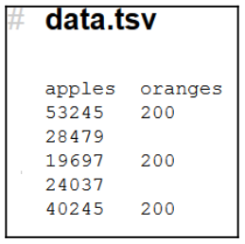

* For our data, we will have three fields (one for each shift): first, second, and third. After having summarized our data, we see the following:

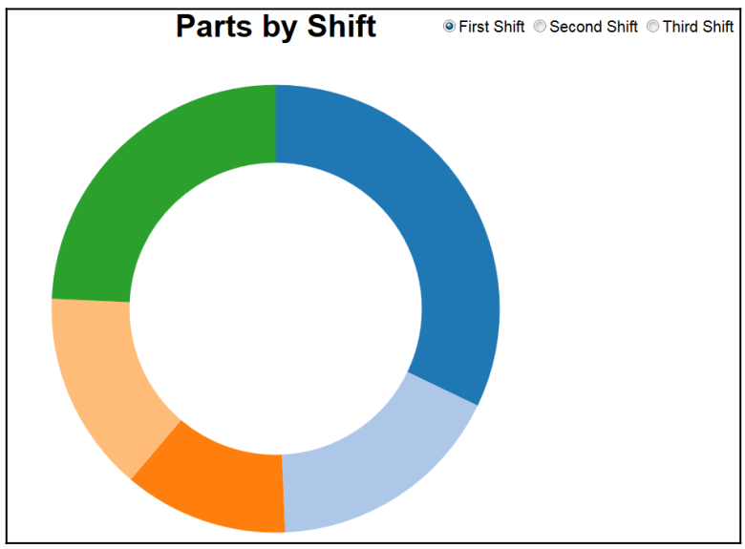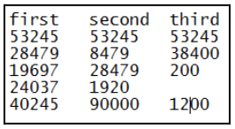

* 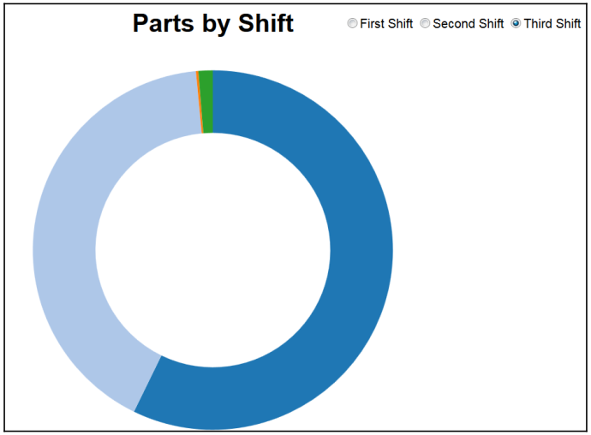The third shift looks as follows:



**11. Explain the steps to handle negative values using D3.**

1. Download the template and save it as an HTML document.



2. Modify the src= reference to be a local reference.

3. Add a heading.

4. Change the file name reference.

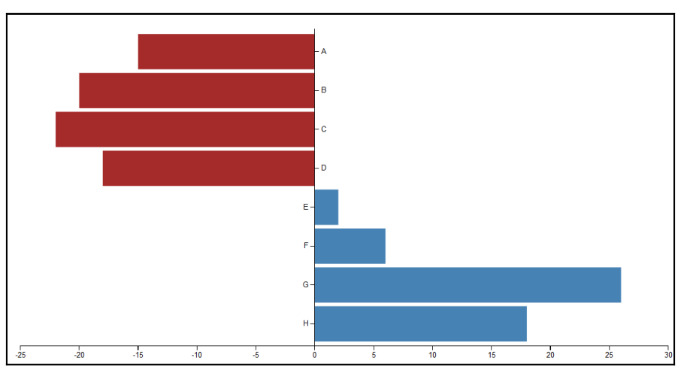

**Ten Marks**

**1.Apply transitions, show the ability to change the shift and display the visualization update by donut pie chart using D3.**

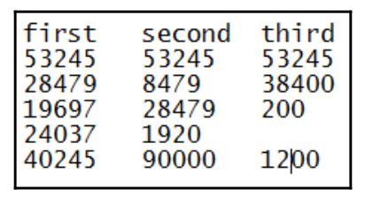

The procedure of clicking on the HTML radio buttons to change the format of the visualization is known as transitioning.

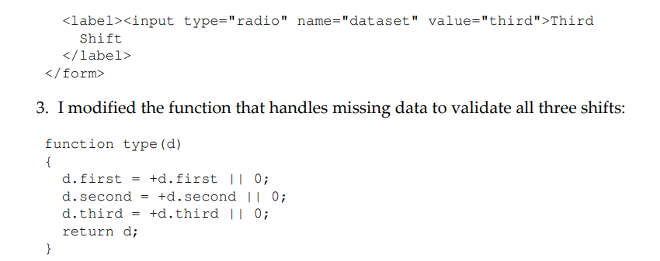

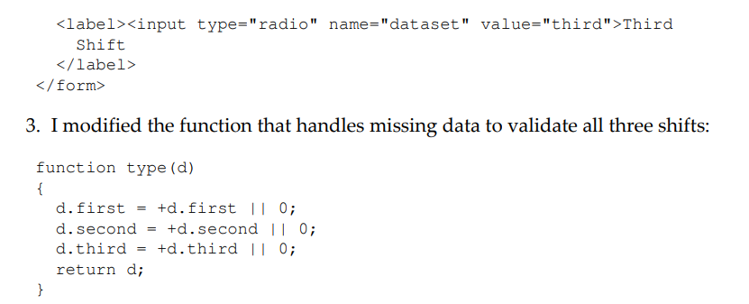 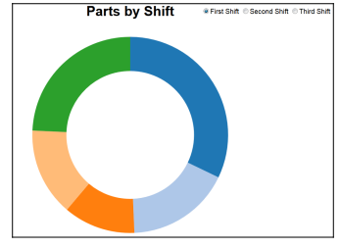

**2. Apply transitions and visualize the relationship between apples and oranges by donut pie chart using D3.**

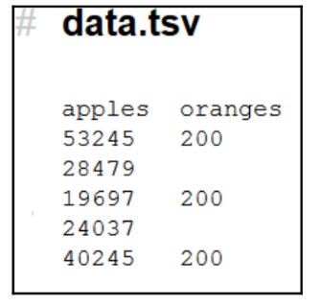

1. I added a simple heading:

# Pie chart

1. I modified the HTML form,

Top of Form

<form>

<label><input type="radio" name="dataset" value="apples"

checked>apples

</label>

<label><input type="radio" name="dataset" value="oranges"

checked>oranges

</label>>

</form>

3. I modified the function that handles missing data to validate all three shifts:

function type(d)

{

d.apples = +d.apples || 0;

d.oranges = +d.oranges || 0;

return d;

}

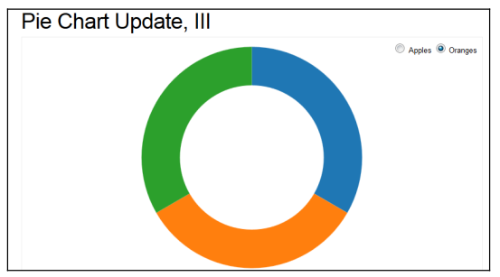Top of Form

**3. Illustrate how color can impact the overall tone of a visualization with an example.**

**Color considerations with a dark background**

Can you provide a case study that demonstrates the importance of considering colour choices when designing with a dark background, using your own example as an illustration?

**Answer:**

When it comes to communicating data, I don’t typically recommend anything other than a white background. Let’s take a look at what a simple graph looks like on a white, blue, and black background.

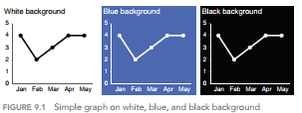

* From the figure, With the white background, I find it easy to focus on the data. The dark backgrounds, on the other hand, pull my eyes there—to the background—and away from the data.
* Light elements on a dark background can create a stronger contrast but are generally harder to read. Because of this, I typically avoid dark and colored backgrounds.
* sometimes there are considerations outside of the ideal scenario for communicating with data that must be taken into account, such as your company or client’s brand and corresponding standard template.
* This was the challenge I faced in one consulting project. I didn’t recognize this immediately. It was only after I had completed my initial revamp of the client’s original visual that I realized it just didn’t quite fit with the look and feel of the work products I’d seen from the client group.
* Their template was bold and in your face with a mottled, black background spiked with bright, heavily saturated colors.
* In comparison, my visual felt rather meek. Figure 9.2 shows a generalized version of my initial makeover of a visual displaying employee survey feedback.

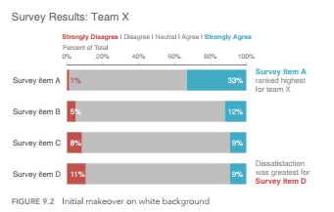

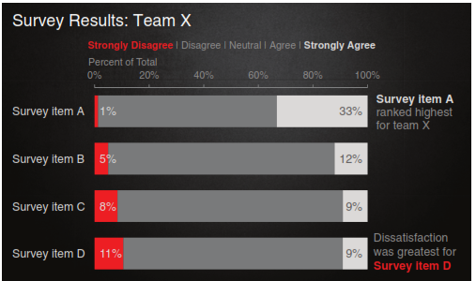

**4.Could you present a case study highlighting the significance of logic in determining the sequence for displaying information, using your own example for illustration?**

**Or**

**You work at a company that sells a product that has various features. You’ve recently surveyed your users to understand whether they are using each of the features and how satisfied they’ve been with them and want to put that data to use. How satisfied have you been with each of these features? Justify the statement “There should be logic in the order of the data you show”.**

Answer:

* There should be logic in the order in which you display information.
* The above statement probably goes without saying. Yet, like so many things that seem logical when we read them or hear them or say them out loud, too often we don’t put them into practice. This  
  is one such example.
* While I would say my introductory sentence is universally true, I’ll focus here on a very specific example to illustrate the concept: leveraging order for categorical data in a horizontal bar chart.
* First, let’s set the context. Let’s say you work at a company that sells a product that has various features. You’ve recently surveyed your users to understand whether they are using each of the features and how satisfied they’ve been with them and want to put that data to use. The initial graph you create might look something like Figure 9.12. How satisfied have you been with each of these features?

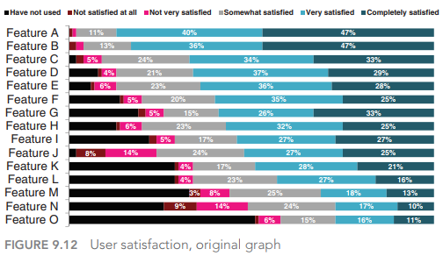

* Figure 9.12 shows the actual graph that was created for this purpose, with the exception that I’ve replaced the descriptive feature names with Feature A, Feature B, and so on.
* There is an order here—if we stare at the data for a bit, we find that it is arranged in decreasing order of the “Very satisfied” group plus the “Completely satisfied” group (the teal and dark teal segments on the right side of the graph).
* This may suggest that is where we should pay attention. But from a color standpoint, my eyes are drawn first to the bold black “Have not used” segment. And if we pause to think about what the data shows, it would perhaps be the areas of dissatisfaction that would be of most interest.
* Part of the challenge here is that the story—the “so what”—of this visual is missing. We could tell a number of different stories and focus on a number of different aspects of this data. Let’s look at a couple of ways to do this, with an eye towards leveraging order.
* First, we could think about highlighting the positive story: where our users are most satisfied. See Figure 9.13.

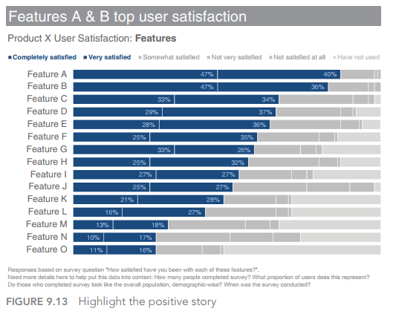

* In Figure 9.13, I’ve ordered the data clearly by putting “Completely satisfied” plus “Very satisfied” in descending order—the same as in the original graph—but I’ve made it much more obvious here through other visual cues (namely, color, but also the positioning of the segments as the first series in the graph, so the audience’s attention hits it first as they scan from left to right). I’ve also used words to help explain why your attention is drawn to where it is via the action title at the top, which calls out what you should be seeing in the visual.
* We can leverage these same tactics—order, color, placement, and words—to highlight a different story within this data: where users are least satisfied. See Figure 9.14.

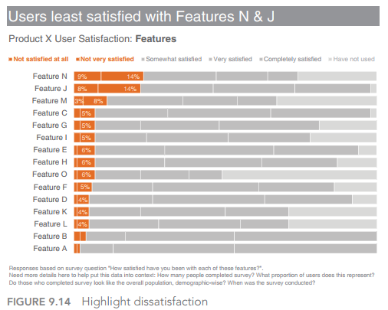

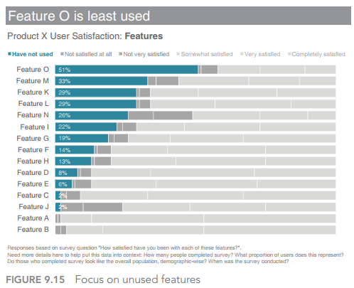

* Note that in Figure 9.15, you can still get to the differing levels of satisfaction (or lack thereof) within each bar, but they’ve been pushed back to a second‐order comparison due to the color choices I’ve made, while the relative rank ordering of the “Have not used” segment is the clear primary comparison on which my audience is meant to focus.
* If we want to tell one of the above stories, we can leverage order, color, position, and words as I’ve shown to draw our audience’s attention to where we want them to pay it in the data. If we want to tell all three stories, however, I’d recommend a slightly different approach.

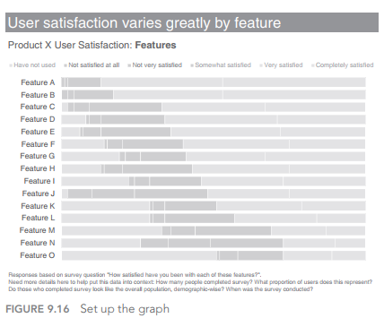

* Figure 9.16 depicts our base visual, without anything highlighted. If I were presenting this to an audience, I’d use this version to walk them through what they are looking at: survey responses to the question, “How satisfied have you been with each of these features?”—ranging from the positive “Completely satisfied” at the right to “Not satisfied at all” and, finally, “Have not used” at the far left (leveraging the natural association of positive at the right and negative at the left).
* Then I’d pause to tell each of the stories in succession. First comes a visual similar to what we started with in the last series that highlights where users are the most satisfied. In this version, I’ve leveraged different shades of blue to draw attention not only to theproportion of users who are satisfied but specifically to Features A and B within those segments that rank highest, tying these bars visually to the text that illustrates my point. See Figure 9.17.

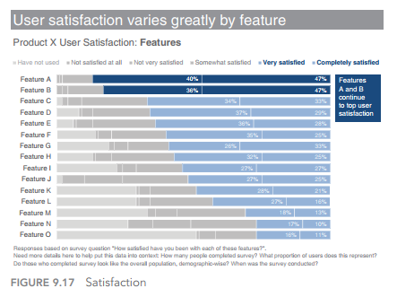

* This is followed by a focus on the other end of the spectrum to where  
  users are least satisfied, again calling out and highlighting specific points of interest. See Figure 9.18.

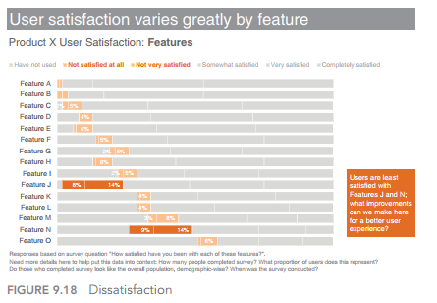

* Note how it isn’t as easy to see the relative rank ordering of the features highlighted in Figure 9.18 as it was when they were put in descending order (Figure 9.14) because they aren’t aligned along  
  a common baseline to either the left or the right.
* We can still relatively quickly see the primary areas of dissatisfaction (Features J and N) since they are so much bigger than the other categories and because of the color emphasis. I’ve added a callout box to highlight this through text as well.
* Finally, preserving the same order, we can draw our audience’s attention to the unused features. See Figure 9.19.

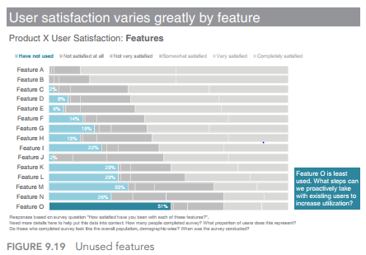

* The preceding views show the progression I’d use in a live presentation. The sparing and strategic use of color lets me direct my audience’s attention to one component of the data at a time. If you are  
  creating a written document to be shared directly with your audience, you might compress all of these views into a single, comprehensive visual

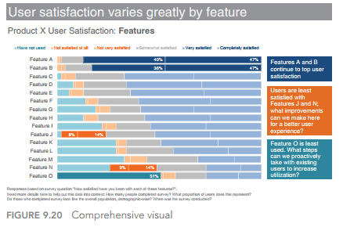

**5.The following table shows the total number of products produced for each machine ID, broken out by shift. Create the bar chart and write the procedure to visualize the total pieces and Machines using D3.**

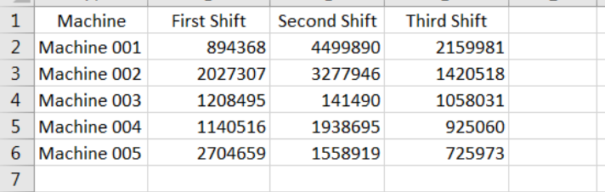

1. Download the grouped bar HTML template document.

2. Open the document in any HTML editor (or any programmer's editor).

3. Under the document's <body> tag, enter or modify the following code:

<body>

<! --- added a simple heading -->

<h1><center>Total Parts by Shift</cellspacing></h>

<! --- local include for D3 libraries -->

<script src="D3.v3.min.js"></script>

4. What this modification does is to add text (Total Parts by Shift) to be used

as our visualization's heading and changes the reference to the D3 libraries (the src= D3.v3.min.js) to be a local reference.

1. Next, again assuming our data file is in the same local location as our HTML file, we can find the document's file reference (D3.csv) and verify the filename: D3.csv("data.csv", function(error, data) { Once we've saved the updated HTML document, we can view it using any web browser. Voila! We've created our first big data visualization using D3:

